

Boeing Autonomous

Engineering Calculations Summary

Elise Chantegros, Budget Liaison
Selina Cozens, Project Manager
Jacob Keeland, Brakes & Manufacturing
Marek Lemieux, CAD Lead
Desirae Mangum, Fundraising Lead
Natasa Peric, Capstone Lead
Lily Quintanar, Intra-group Communications



Spring 2026

Sponsors/Technical Mentors: Donald Guzman and Connor Nolan
Instructor: Professor David Willy
Group Number: F25toSp26_02
Introduction
In this report, Boeing Autonomous will summarize all current progress made for both past and current semesters. Sections will be divided by sub-team to organize current top-level design assemblies, codes/standards being referenced, calculations, diagrams, charts, and additional resources. As a team, the goal for this report is to reassure our clients that the team can execute their solutions off paper.

Top Level Design Summary
This section will go into each sub-team’s problem and its proposed solution. A top-level CAD will be included to aid in visibility. Each top-level CAD will include balloons and leader line notes to help depict what is being shown, along with a description of any additional subsystems that are included to aid in the subfunction’s functionality. All sub-teams are given the same customer requirements (CR’s) however, the engineering requirements (ER’s) are specialized for each team. An updated QFD will be used to compare each ER and CR to determine the most important ER that each sub-team could focus on. Below is a drawing of where each sub-team’s assembly will be located.

Problem Statement
The goal of this project is to develop an actuation and control system that can be retrofitted onto an existing vehicle, such as a go-kart. The system will focus on controlling three main functions of the vehicle: brakes, steering, and throttle through hydraulic and electronic actuators. The vehicle should be able to function autonomously once these subsystems connect to open-source self-driving software. Its data will be collected through sensors for the system to provide support to the algorithms, such as lane-following assistance and obstacle detection.

Top-Level CAD
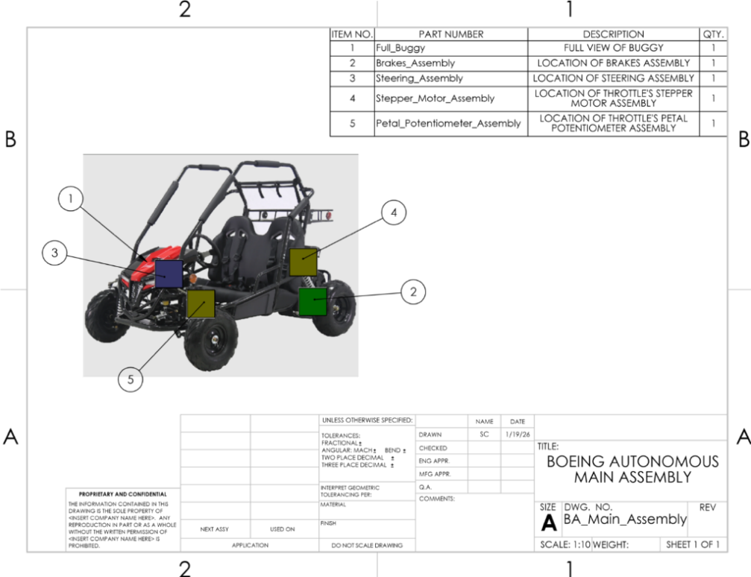
Figure 1: Full Assembly of all Sub-Teams
General Engineering and Customer Requirements
This section details the client-specified needs, including autonomous navigation, obstacle detection and avoidance, manual override, real-time state monitoring, safety features, and performance criteria such as speed limits and battery life. All sub-teams are given these requirements.

Engineering Requirements
The system's obstacle detection and avoidance algorithms shall have a response time of less than 500ms to ensure safe operation. The buggy's top autonomous speed shall be no more than 15 kph (9.5 mph). The system shall operate for a minimum of 20 minutes on a single battery charge during continuous autonomous operation.

Customer Requirements
- Autonomous Navigation – The buggy must autonomously navigate a predefined path from a starting point to a destination without human intervention.

- Obstacle Detection and Avoidance – The buggy must detect static and dynamic obstacles and adjust its trajectory to avoid collisions safely.

- Manual Override – The system must allow the user to control the buggy through a mechanical interface, enabling manual operation to override autonomous functions.

- Real-Time State Monitoring – The buggy must provide real-time feedback to a user interface. Critical information must be displayed, such as battery life, current speed, and any applicable live video to monitor operational status.

- Emergency Stop Mechanism – The buggy must include a physical emergency stop button that immediately and safely halts the vehicle.

- Fail-Safe Design – The system must stop safely in the event of a critical component failure.

- Battery Life for Continuous Operation – The buggy must operate autonomously for a minimum of 20 minutes on a single battery charge.

- Support for Driver Assistance and Autonomous Modes – The system must support both driver assistance and autonomous modes to allow flexibility in operation.

- Actuator Control for Subfunctions – The system must enable lane-keeping assist and other driver aids by controlling the buggy’s main subfunctions.

- Integration with Open-Source Autonomous Platforms – The system must integrate with open-source self-driving software and sensor data to enable autonomous driving capabilities.

- Prioritized Safety Features – The system must prioritize safety features like emergency stop, watchdog timers, and validated fail-safe mechanisms.

- Closed-Course Testing with Controlled Parameters – The system must be tested on a closed course with defined performance parameters (e.g., speed, path accuracy, obstacle avoidance) to validate its functionality and reliability.

- Comprehensive Documentation and Handover – The project must deliver a complete handover package, including a System Requirements Document (SRD), Requirements Traceability Matrix (RTM), Interface Control Document (ICD), CAD models, Bill of Materials (BOM), software integration details, test reports, and a prototype demonstration of how to use the self-driving features.

Brakes
The brakes of a vehicle are one of the most important safety features. Not only are they required for safety, but they also allow increased control over the vehicle itself. Plenty of drivers overlook the skills needed to identify when the brake needs to be actuated, how hard the pedal needs to be pushed, and estimate where the vehicle will be when the brake action is finished. Thus, the biggest challenges faced in making autonomous brakes are those actions previously mentioned.

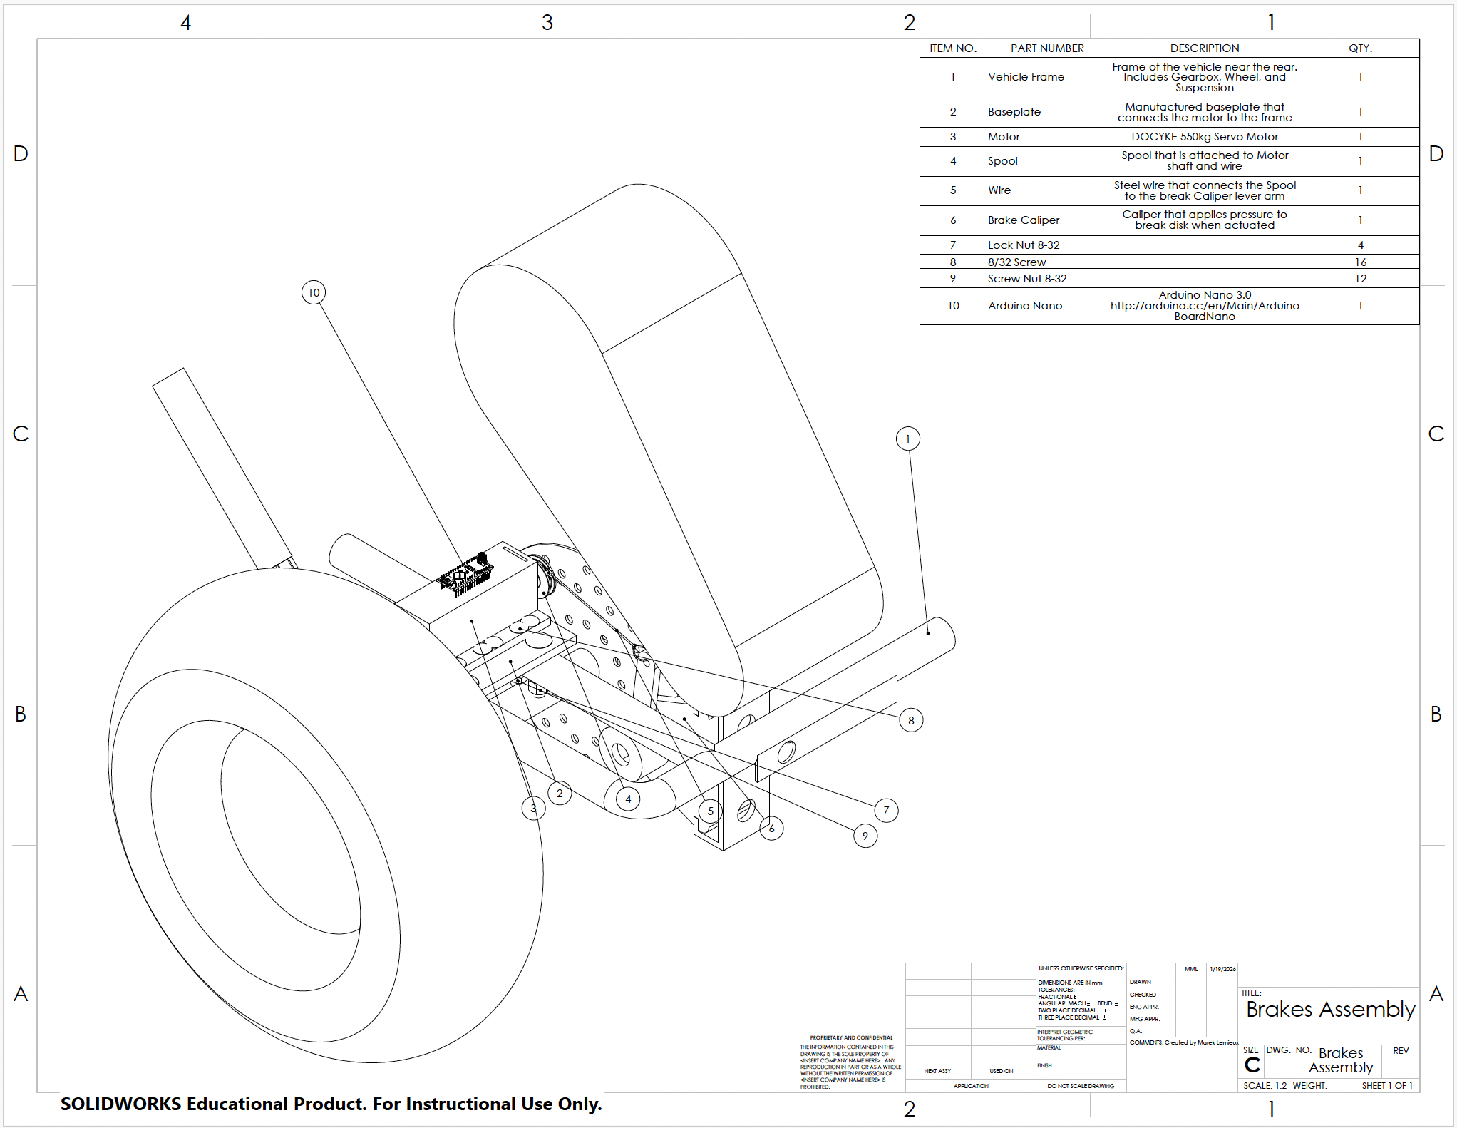
Figure 2: Brakes Assembly Drawing

- Subassemblies
Three major subsystems integrate to perform the autonomy of the brake sub-team.
- Mounting subsystem – This subsystem is comprised mainly of two parts. These are the mounts for the motor assembly and the brake caliper, respectively. Analysis is planned to be done on the final prototypes to ensure failure points will not result in catastrophic failure.
- Bridge subsystem – This subsystem is intended to be a bridge for the torque in the motor shaft to transfer to a force on the brake disk. The bridge comprises the spool, steel wire, and lever arm on the brake caliper.
- Electrical subsystem – The electrical subsystem is in control of how and when the brakes actuate. With an Arduino, Raspberry Pi, and some software, it can effectively actuate the motor to four or five different brake settings, making the vehicle slow or stop when needed.

- Engineering Requirements
To meet the goals set by the capstone, there are multiple engineering requirements set by the brake sub-team. These requirements are set specifically for the brake sub-team however; they could apply to other sub-teams.
- Autonomous Brake Response Time of ≤ .5s
- Emergency Stop Time: 2s
- Runtime per charge: ≥ 1hr
- User Brake Input Force ≤ 53.38N
- Max Line Pressure = 10.1MPa
- System Operable for ≥ 20 minutes
- On/Off Switch
Steering
The problem the steering sub-team is trying to address is “How can the steering wheel move mechanically during autonomous function?” To answer this question, the steering sub-team has proposed the solution of utilizing a motor and a gear train to rotate the steering shaft. Additionally, for mounting, casings have been made for an electrical box to protect electrical items such as an Arduino Nano and a motor box to hold and secure the motor in place. Currently, the steering sub-team is focused on manufacturing a gearbox to protect the driver and the gears from external factors. For a clearer depiction of the steering sub-team’s current proposed solution, a top-level CAD of the steering assembly is included in Figure 3.

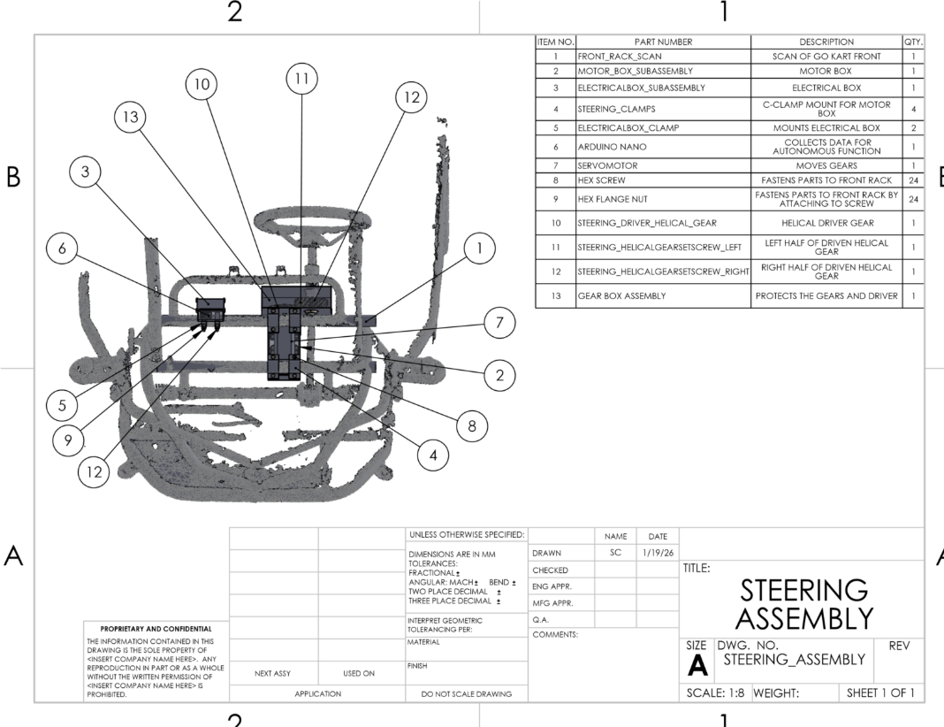
Figure 3: Top-Level Steering Assembly

- Subassemblies:
Within Steering’s top-level CAD, there are multiple sub-assemblies that contribute to its functionality. A list of each subassembly and a definition of its purpose is provided below.
  - Motor Box (Balloon 2) – Holds the motor in position to align the driver gear with the driven gear. This casing provides holes to secure the motor with bolts and nuts.
  - Electrical Box (Balloon 3) – Contains and protects all the steering sub-team’s electrical components that are needed to control the mechanism.
  - Gear Box (Balloon 13) – Protects the gear train needed to rotate the steering shaft and the driver from any potential accidents.

- Engineering Requirements
  - Minimum Turning Radius (7m)
  - Max Rotation Range (900°)
  - Minimum Autonomous Torque (2.5Nm)
  - Minimum User Torque (2Nm)
  - Max Autonomous Turning Velocity (10kph)
  - Max Autonomous Turning Acceleration (15km/(h*s))
  - Response time (< 500ms)

Throttle
The throttle sub-team addresses how the throttle will be actuated in autonomous mode while still maintaining full functionality during manual operation. To address this question, the sub-team is working on a system that allows for manual and autonomous actuation while having a mechanical fail-safe in case of electronic failure. In manual mode, a potentiometer mounted at the pedal will measure pedal position and transmit this signal to a stepper motor located at the rear of the kart, which will actuate the throttle lever accordingly. The team is currently refining the stepper motor mounting mechanism and finalizing the design of the potentiometer mounting mechanism.

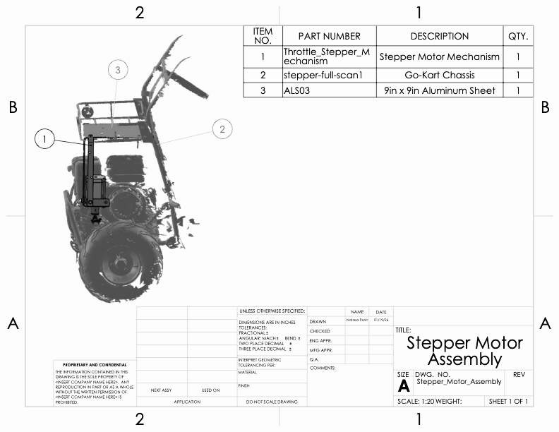
Figure 4: Stepper Motor Assembly for Throttle Mechanism

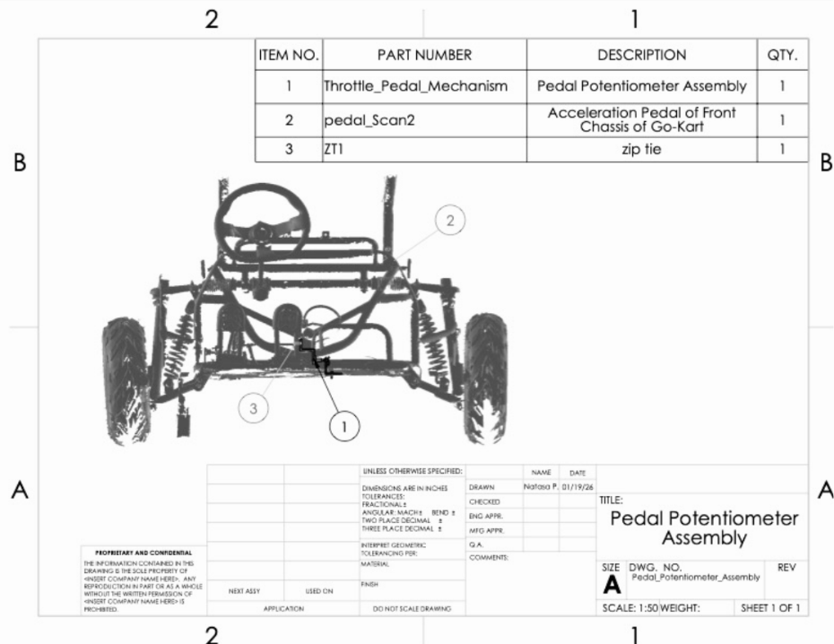
Figure 5: Pedal Potentiometer Assembly

- Subassemblies:
The major subassemblies for the throttle mechanism are listed below.
  - Stepper Motor Mount (Figure 4) - Holds the stepper motor in place, aligning it with the Bowden cable.
  - Pedal Potentiometer Mount (Figure 5) - Connects the potentiometer tip to the pedal so that pressing the pedal moves the potentiometer tip, indicating the pedal position and sending this information to the stepper motor
- Engineering Requirements:
  - Pedal Force: 19-29 N
  - Manual Override Force: 19-22 N
  - Actuation Response Time: 37-54 ms
  - Manual Override Response Time: <500 ms
  - Throttle Cable Velocity: 0.46-0.66 m/s
  - Maximum speed: 15 mph
  - Power consumption: <100 W

House of Quality
A House of Quality (HoQ) is a tool designed to quickly highlight the key components of an engineering design and compare it to what is most important to their clients. This is done with a matrix format that includes ranking the design on a scale of 1-10 in categories and then totaling the score of the graded design to compare against competitors. Competitors for Boeing Autonomous were Tesla, Waymo, and Cruise, as they are currently leading in the autonomous vehicle market.

Brakes:
For specifically the brake sub-team, the main focus was on obstacle detection, obstacle avoidance, and safety. Focusing on these categories allows the team to focus their efforts on the functionality and safety of the autonomous brake mechanisms.

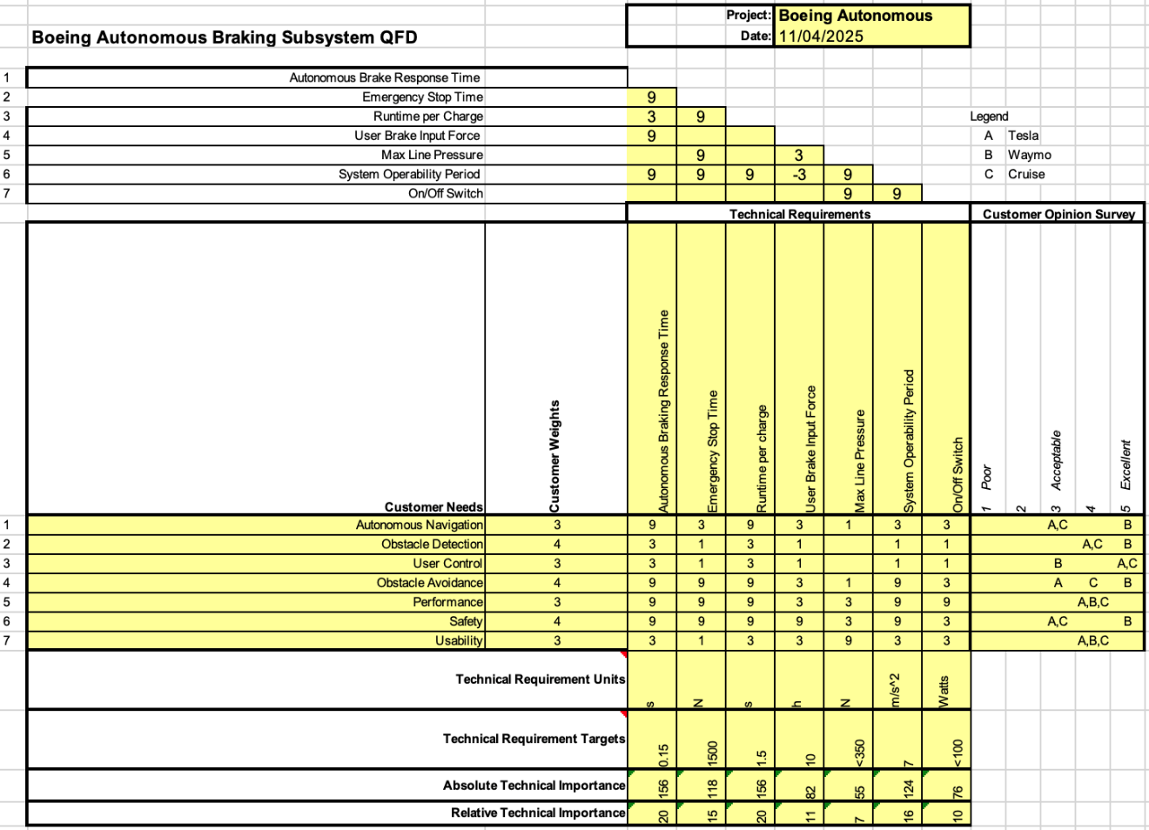
Figure 6: Brake HoQ

Steering:
The HoQ for steering displays the customer’s needs and weights that were derived from a list of CR & ER’s given by the clients. For the CR’s, the steering sub-team will be focused on autonomous navigation, obstacle detection, user control, obstacle avoidance, performance, safety, and usability. The clients’ needs were compared with those of the three companies for benchmarking: Tesla, Waymo, and Cruise. The technical requirements are response time, minimum turning radius, max rotation, minimum autonomous torque, minimum user torque, maximum autonomous turning velocity, and maximum turning acceleration. As depicted in Figure 7, response time was determined to be the most important technical requirement based on the weighted customer needs.

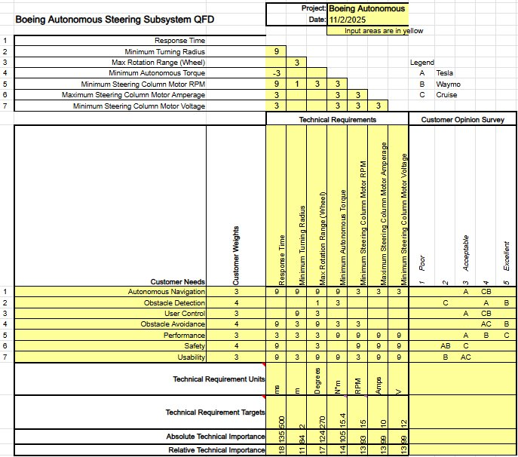
Figure 7: Steering HoQ
Throttle
The QFD for the throttle subsystem followed similar criteria to those for the brakes and steering systems. However, its success mainly depends on pedal force and manual override force, along with other technical requirements such as actuation response time, manual override response time, cable velocity, maximum speed, and power consumption. These were then compared to customer needs such as autonomous navigation, user control/manual override, state monitoring/diagnostics, performance, safety, and usability. The customer surveys from Tesla, Waymo, and Cruise helped compare these needs. Through the QFD process, pedal force and manual override force were the most relevant criteria for designing the throttle mechanism. The sub-team concluded that pedal force significantly impacts the go-kart’s safety and efficiency.

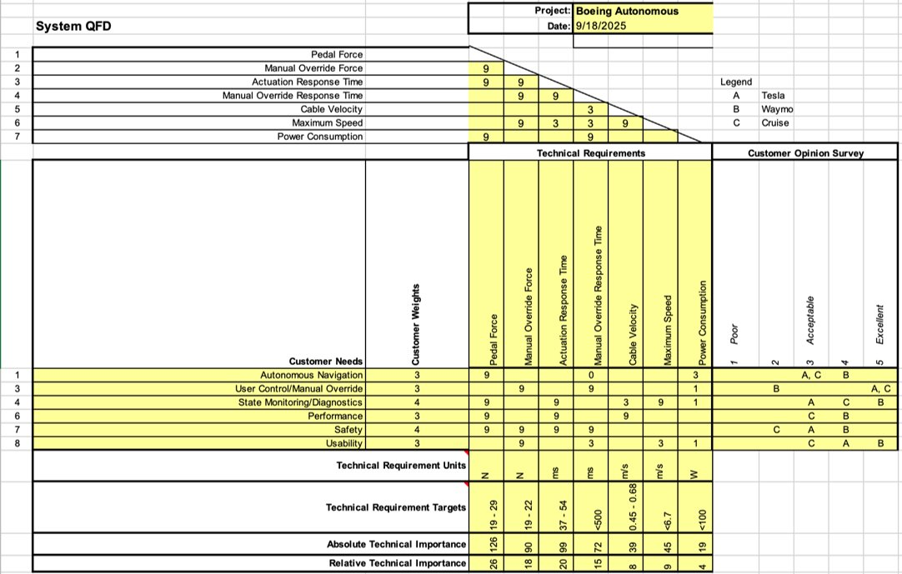
Figure 8: Throttle HoQ

Summary of Standards, Codes, and Regulations
The following summary contains a list of standards, codes, and regulations that the team has used to assess the road requirements and proper safety protocol while modifying the go-kart. These rules are significant in ensuring that the changes made to the go-kart will keep a passenger safe at all times and that no modifications will be used that can potentially cause harm to the passenger or the individuals around them.

Brakes
- Title 28 Chapter 3 Article 4 28-661 to 28-666 (Arizona Revised Statutes) [1]
  - These articles describe the procedures in cases with autonomous vehicles and accidents. It is particularly important for brake team as it is related to the critical features of the sub team.

Steering
- ISO 22737 – Low Speed Automated Driving [2]
  - While this standard more specifically addresses vehicles on predefined routes, it can still be applicable because of the vehicle’s low speed. It addresses the development and testing of steering-heavy situations such as parking and high traffic. These guidelines aid in the design and future testing processes of the steering system.
- SAE J2530 / J266 – Steering system performance & testing [3]
  - This SAE standard sets guidelines for steady state directional control steering and testing. This applies to testing the automated system later on to record its behavior while the steering wheel is consistently pointed in one direction.

Throttle
- ISO 26262 – Functional Safety [4]
  - Although ISO 26262 is written for road vehicles, its functional safety principles are used as guidance for this project. The standard focuses on preventing unintended behavior in safety-critical systems such as throttle control. These ideas guide the throttle sub-team's design choices, including separating manual and autonomous control and ensuring safe and predictable throttle actuation. Using these principles helps reduce the risk of unintended acceleration and improves system safety
- ISO 12100 – Safety of Machinery [5]
  - ISO 12100 provides general guidelines for identifying hazards and reducing risks in mechanical systems. Although it is not specific to go-karts, its principles are used to guide the mechanical design of the throttle system. This includes evaluating risks related to moving parts, pinching points, and component failure, particularly for the stepper motor and potentiometer mounts. Applying these principles helps ensure that components are securely mounted, protected from damage, and safe to operate in both autonomous and manual modes.

Summary of Equations and Solutions
The following set of equations and solutions is how each sub-team obtained definitive values for the creation and modification of their designs. Each sub-team has assessed its load cases and associated equations to define how these results influence the outcome of its design. Moreover, the factor of safety for each load case has been used to define the integrity of each scenario, offering a deeper analysis of the success of each subsystem.

Brakes
- Load Cases (Jacob)
  - Quasi-static test: Caliper clamped to 11.5 Nm using the adjuster screw. Go-kart positioned stationary on a flat surface. Force was measured via a scale pressed horizontally against the frame until rear-wheel slippage occurred. Measured resistance allows for reverse calculation of clamping force, cable tension, and required servo torque.
- Equations and Solutions
  - This analysis calculates the required clamping force, cable tension, and servo torque to achieve full rear-wheel lockup (analytical case) or match measured resistance (quasi-static test), then compares to the servo’s peak capability to confirm substantial excess capacity.

Variables:
- $τ_{Rotor}=11.5Nm$
- $μ_{Pad on Rotor}=0.42$
- $r_{Brake Pad Radius}=0.062m$
- $r_{Spool Radius}=0.017m$
- $F_{Max Clamp}=221N$
- $M_{Me. Advantage}=2.94$
- $T_{Cable Tension}=38N$
- $η_{System Efficiency}=0.94$
- $τ_{Required}=3Nm$
- $τ_{Max}=35Nm$
Equations:
FMax Clamp=τRotor2μPad on Rotor⋅rpad#FMax Clamp=τRotor2μPad on Rotor⋅rpad
TCable Tension=FMax2μPad on Rotor⋅rBrake Pad Radius#TCable Tension=FMax2μPad on Rotor⋅rBrake Pad Radius
$$\begin{aligned}τ_{Required}=\frac{T⋅r_{Spool Radius}}{η_{Efficiency}}\end{aligned}$$
$$\begin{aligned}FoS=\frac{τ_{Max}}{τ_{Required}}\end{aligned}$$
Results and Conclusion:
The calculated clamping force of 221 N results in 38 N cable tension and a servo torque requirement of 3 Nm. With the Docyke rated at 35 Nm, the torque factor of safety is 12. The chain is validated by the quasi-static test data. System meets requirements with margin.

Table 1: Brakes Minimum FoS
Sub-System | Focus | Load Case Scenario | Material | Methods of Calculating FoS | Minimum FoS
Mechanical Brake Caliper | Clamping force and mechanical advantage | Quasi static full clamp: 383N constant force to overcome | Steel | Hand Calculated and Measured |  | 1
Cable & Servo | Torque Output | Pull 38N cable at 0.017m, 94% efficiency | Steel & Hardened Plastic | Measured and Calculated |  | 1
 |  |  |  | Torque FoS |  | 12

Steering
- Set Screw Shear Stress Analysis (Selina Cozens)
The steering sub-team is looking to purchase steel gears containing shafts with set screws for their assembly. Given the variables and constraints, further analysis is conducted to determine if the provided set screws with Loctite blue applied could withstand the required force to move the wheel as shown below.

  - Assumptions:
    - Loctite Blue is assumed to prevent any loosening of the screw-pin
    - Ignore threads
    - Set screws will be the same material as the gears
    - Steel material is 1018 CD
  - Variables:
    - Steel Material Properties [6]
      - Yield Strength ($S_{y}$) = 370 MPa [6]
    - F = 73.4 N
    - $A_{p}$ = 7.07 mm^2
    - $A_{g}$ = 19.63 mm^2
- Equations:
  - Allowable Shear Stress [6]:
$$\begin{aligned}τ_{allow}=\frac{S_{y}}{\sqrt{3}}\end{aligned}$$
- Shear Stress [6]:
$$\begin{aligned}τ=\frac{F}{A}\end{aligned}$$
- Factor of Safety (FoS) [6]:
$$\begin{aligned}FoS=\frac{τ_{allow}}{τ}\end{aligned}$$

- Conclusion:
For both set screws, the allowable shear stress is 213.62 MPa. For the pinion and gear set screws, their calculated shear stress is 10.38 MPa and 3.74 MPa, respectively. Since both shear stresses are less than the allowable shear stress, mathematically, if the set screws were steel, they would work. This calculation would validate the purchase of the set screws.
When calculating the factor of safety, the pinion and gear values for the set screws are 20.58 and 57.12. Both values are over 1, clarifying that material strength is not the limiting factor. Although the set screws are safe in shear, there may be other failure modes such as slip at the shaft interference or loosening under vibration, which are expected to govern the design. More calculations will be made in the future to consider these external factors.

- Gear System Stress Analysis (Desirae Mangum)
The steering sub-team is looking to purchase steel spur gears for their assembly. Given the variables and constraints, further analysis is conducted to determine the factor of safety for the material of the purchased gears and if the gears could withstand the required force to move the wheel, as shown below.

- Assumptions:
  - Material is 45 Carbon Steel
  - All forces are concentrated at the midpoint of the tooth
  - Reliability Factor ($Y_{Z}$) = 1.00
  - Temperature Factor ($Y_{θ}$) = 1.0
- Variables:
  - Steel Material Properties [7]
  - F = 73.4 N
  - $N_{g}$= 50T
  - $N_{p}$= 20T
  - $d_{g}$= 78mm
  - $d_{p}$= 33mm
  - $b_{g}$= 12mm
  - $b_{p}$= 10mm
  - $m_{tg}$ = 1.56mm
  - $m_{tp}$ = 1.65mm
  - K Values:
$K_{o}$ = 1.00 [6] $K_{v}$ = 1.20 [6] $K_{s}$ = 1.00 [6]
$K_{H}$ =1.196 [6] $K_{B}$ = 0.668 [6] $K_{B}$ = 0.085 [6]
  - $Y_{Jg}$ = 0.30 [6]
  - $Y_{Jp}$ = 0.33 [6]
  - $Z_{E}$ = 8.169 $\sqrt{N/{mm}^{2}}$ [6]
  - $Z_{R}$ = 1 [6]
  - $d_{wl}$ = 33mm
  - $Z_{I}$ = 0.098 [6]
  - $S_{t}$ = 379.2 $N/{mm}^{2}$ [6]
  - $Y_{N}$ = 1.017 [6]
  - $S_{c}$ = 1241.056 $N/{mm}^{2}$ [6]
  - $Z_{N}$ = 1 [6]
  - $Z_{W}$ = 1 [6]
- Equations:
  - Bending Stress [6]:
$$σ=W^{t}K_{o}K_{v}K_{s}\frac{1}{bm_{t}}\frac{K_{H}K_{B}}{Y_{J}}$$
  - Contact Stress [6]:
$$σ_{c}=Z_{E}\sqrt{W^{t}K_{o}K_{v}K_{s}\frac{K_{H}}{d_{wl}b}\frac{Z_{R}}{Z_{I}}}$$
  - Safety factor for bending [6]:
$$S_{F}=\frac{{S_{t}Y_{N}}/{(Y_{θ}Y_{Z})}}{σ}$$
  - Safety factor for Contact [6]:
$$S_{H}=\frac{{S_{C}Z_{N}Z_{W}}/{{(Y}_{θ}Y_{Z})}}{σ_{C}}$$

  - Allowable Bending Stress [6]:
$$σ_{all}=\frac{S_{t}}{S_{F}}\frac{Y_{N}}{{Y_{θ}Y}_{Z}}$$
  - Allowable Contact Stress [6]:
$$σ_{all,c}=\frac{S_{c}}{S_{H}}\frac{Z_{N}Z_{W}}{Y_{θ}Y_{Z}}$$
  - Factor of Safety (FoS) [6]:
$FoS=\frac{σ_{all}}{σ}$

- Conclusion:
For the pinion and gear, the allowable bending stress is 1.644 $N/{mm}^{2}$and 12.53 $N/{mm}^{2}$, respectively. For the pinion and gear, their calculated bending stress is 1.644 $N/{mm}^{2}$and 12.53 $N/{mm}^{2}$, respectively. For the pinion and gear, the allowable contact stress is 14.743 $N/{mm}^{2}$and 13.458 $N/{mm}^{2}$, respectively. For the pinion and gear, their calculated contact stress is 14.743 $N/{mm}^{2}$and 13.458 $N/{mm}^{2}$, respectively. Since both are equal to the allowable bending and contact stresses, mathematically, the gears’ material will work. This calculation would validate the purchase of the gears.

- Gear Ratio Calculation (Lily Quintanar)
To purchase the correct gears, the steering sub-team must know the gear ratio necessary for the system to properly work. Having the correct gear ratio means that the torque needed to operate the steering wheel will be applied when the servo motor and gears are in use.
- Assumptions:
  - Ideal gears
  - The force is applied at pitch radius
  - There are no dynamic effects
- Variables
  - $r_{pinion}$=0.0165 m
  - $r_{gear}$= 0.034 m
  - F=73.4 N
  - $θ$= 90$°$
- Equations
  - Input Torque
$$\begin{aligned}τ_{in}=Ϝ*r_{pinion}\sin\left(θ\right)\end{aligned}$$
  - Output Torque
$$\begin{aligned}τ_{out}=Ϝ*r_{gear}\sin\left(θ\right)\end{aligned}$$
  - Gear Ratio
$$\begin{aligned}Gear Ratio=\frac{τ_{out}}{τ_{in}}\end{aligned}$$
- Conclusion
With an input torque of 1.211 Nm and an output torque of 2.863 Nm, the gear ratio needed is 2.36:1. The gears that the sub-team is looking to purchase have a ratio of 2.5:1, which is more than required. This means that these gears will be ideal for the system.

Table 2: Steering Minimum FoS
Sub-System | Focus | Load Case Scenario | Material | Methods of Calculating FoS | Minimum FoS
Gear System |  |  |  |  | 1
 | Gear Stresses | 2862.6Nmm of Torque Applied to Gear | 45 Carbon Steel | Hand Calculation | 1
 | Pinion Stresses | 1211.1Nmm of Torque Applied to Pinion | 45 Carbon Steel | Hand Calculation | 1
Set Screws |  |  |  |  | 20.58
 | Maximum Shear Stress for Pinion Screw | 73.4N of Force Applied to Set Screws in single shear | 1018 CD Steel | Hand Calculation | 20.58
 | Maximum Shear Stress for Gear Screw | 73.4N of Force Applied to Set Screws in single shear | 1018 CD Steel | Hand Calculation | 57.12

Areas of Concern: With the gear system only having a factor of safety of 1, it is important to be aware of any signs of failure. As the gears are obtained, this factor will change, with the knowledge of more variables that can be confirmed.

- Design Insight
Each of these calculations confirms that the chosen gears purchased are justified by the engineering calculations required. With these calculations done, the gear system is proven to be a justified design decision, from gear to pinion. Highlighting the set screws' factor of safety confirms that the purchased screws will be enough to withstand the mechanical demands. Leaving more time to focus on manufacturing the gearbox to the best ability.

Throttle
- Load Cases
  - The conditions that led to the listed load cases analyzed for the throttle design included the range of force on the pedal, the minimum velocity of the throttle’s cable, and the torque range of the spool at full throttle. The range of the pedal force is necessary to determine how many Newtons the throttle lever must safely apply to the pedal for it to reach full throttle. The velocity of the throttle cable is necessary to determine how its change in distance over time couples with the use of a stepper motor. The torque range of the spool depends on the spool’s design in terms of its diameter, which is crucial to prevent any malfunction in controlling the throttle lever using the stepper.
- Equations and Solutions
  - Pedal Force Range (Elise):
    - This mathematical analysis answers the question of what the range of the pedal force must be using the NEMA 23 stepper motor to reach full throttle. This calculation provides insight in determining what the stepper must be programmed to turn the spool based on the corresponding speed.
Variables:
- F_{scale}, min = 19.60N
- d_{pedal} = 0.0635m
- d_{cable} = 0.039m
- r_{spool} = 0.025m
- 𝑇_{stepper, dynamic} = 1.2Nm [8]
Equations:
$$\begin{aligned}τ_{pedal}=F_{pedal}∙d_{pedal}\end{aligned}$$
$$\begin{aligned}F_{cable}=\frac{τ_{pedal}}{d_{cable}}\end{aligned}$$
$$\begin{aligned}τ_{cable}=F_{cable}∙r_{spool}\end{aligned}$$
$$\begin{aligned}F_{scale, max}=\frac{τ_{stepper, dynamic}}{r_{motor}}∙\frac{d_{cable}}{d_{pedal}}\#\left[9\right]\end{aligned}$$
Factor of Safety (FoS) [6]:
$$FoS=\frac{σ_{all}}{σ_{act}}$$

Results and Conclusion:
The stepper motor can sustain between 20-30N of force on the pedal to reach full throttle. This range is used to finalize the radius of the spool and verify that the stepper motor can provide enough force that offers range from zero to full throttle.
The factor of safety for this was calculated to be 1.53 based on the maximum pedal force. This conclusion supports that 30N of pedal force is sustainable relative to the required minimum of 19.6N.
- Spool Diameter (Natasa):
  - This mathematical analysis answers the question of how large the spool’s diameter must be to ensure that the stepper will provide a sufficient RPM to sustain its associated torque. This calculation is significant in making sure that the stepper is programmed carefully to not cause too high of a torque and jerk the passengers when the go-kart is in motion.
Variables:
- F_{pedal} = 19.6; Units: Newtons (N)
- d_{pedal} = 0.0635; Units: Meters (m)
- d_{cable} = 0.0314; Units: Meters (m)
- T_{max_motor} = 2.4; Units: Newton-meters (Nm)
- v_{dynamicT} = 0.5; Conservative value of dynamic torque
- T_{dynamic_motor} = 1.2; Dynamic/Useable Torque of Motor
- degree_{lever} = 22.7; Angle of throttle lever turn in degrees
- degree_{spool} = 90; Angle the spool will turn in degrees
- I_{motor} = 0.000053; Inertia of Stepper Motor in kg*m^2
- T_{stepper} = 1.2; Useable Torque in Stepper (Nm)
- T_{spring} = 0.03924; Torque of Return Spring (Nm)
- T_{friction} = 0.05; Estimated Torque due to ground (Nm)

Equations:
$\begin{aligned}r_{spool}=\frac{d_{cable}}{θ}\#[10]\end{aligned}$ $\begin{aligned}τ_{pedal}=F_{pedal}∙d_{cable}\end{aligned}$
$$\begin{aligned}F_{cable}=\frac{T_{pedal}}{d_{cable}}\end{aligned}$$
$$\begin{aligned}τ_{cable}=F_{pedal}∙r_{spool}\#[11]\end{aligned}$$
$$\begin{aligned}s=θ∙r_{spool}\end{aligned}$$
$$\begin{aligned}I_{total}=I_{spring}+I_{motor}\end{aligned}$$
$$\begin{aligned}τ_{net}=τ_{stepper}{-τ}_{spool}{-τ}_{friction}\end{aligned}$$
$$\begin{aligned}RPM=\frac{ν_{cable}∙60}{π∙d_{spool}}\#[12]\end{aligned}$$

Results and Conclusion:
Using a 20 mm radius, the spool provides enough torque to effectively pull the throttle in a short response time without overloading the motor through a substantial RPM.
To ensure that the throttle can move autonomously, the spool dimensions demonstrate satisfactory results with a factor of safety of 1.4. The material used for the spool poses a risk due to possible chafing as the throttle lever gets pulled over time.
  - Cable Throttle Velocity (Natasa):
    - This mathematical analysis answers the question of how fast the velocity of the throttle cable is based on its displacement and the stepper motor’s response time. This calculation is crucial in determining what value the range of the velocity must be to accurately overcome the stepper motor’s torque.
Variables:
- $Θ=22.7°$
- $r_{spool}=0.02m$
- $I_{spool}=15.1E-5kg∙m^{2}$
- $I_{stepper}=5.3E^{-5}kg∙m^{2}$
- $d_{cable}=0.0314 m$
- $T_{stepper}=1.25 N∙m$
- $T_{spring}=0.03924 N∙m$
- $T_{friction}=0.05 N∙m$ [13]
Equations:
$$\begin{aligned}{s=θ∙d}_{cable}\#[14]\end{aligned}$$
$$\begin{aligned}I_{total}=I_{spool}+I_{stepper}\end{aligned}$$
$$\begin{aligned}T_{net}=T_{stepper}-T_{spring}-T_{friction}\end{aligned}$$
$$\begin{aligned}t_{cable}=\sqrt{\frac{2∙s*I_{total}}{r_{spool}∙T_{net}}}\#[14]\end{aligned}$$
$$\begin{aligned}v_{cable}=\frac{d_{cable}}{t_{cable}}\end{aligned}$$

Results and Conclusion:
The cable’s velocity will be approximately 0.46 - 0.66m/s for a 23 – 33 ms timeframe. This velocity will help determine the response time range for the electrical input to accurately take feedback from the control system and direct it to the throttle response system.
The factor of safety for the cable’s velocity was found to be 18.3. This result is due to the cable being made of wire rope, which exceeds the inertia and torque-based strength of the throttle mechanism.

Table 3: Throttle Minimum FoS
Sub-System | Focus | Load Case Scenario | Material | Methods of Calculating FoS | Minimum FoS
Pedal Encoder |  |  |  |  | 1.09
 | Encoder Angle | 22.7° Pedal Distance for 19.6N Force (Full Throttle) | 1018 Steel | Force Guage, Hand Calculation | 1.53
 | Encoder Mounting Mechanism | Distributed Load along Pivoted Edges in Mount | PLA Filament and 1018 Steel | FEA Analysis | 1.09
Stepper Motor |  |  |  |  | 1.4
 | Stepper Motor Mount | 1.2kg Stepper Mounted to Top Chassis of Go-Kart | 1018 Steel L-Brackets | Hand Calculation | 14
 | Spool Design | 0.02m Spool Radius Attached to Stepper | PLA Filament | Hand Calculation | 1.4
 | Cable Velocity | Velocity of the Cable to Reach Full Throttle | Aluminum | Hand Calculation | 18.3

  - Areas of Concern:
- The pedal encoder is positioned near a high-traffic area in which it can be kicked by a passenger, so it will need a protective enclosing to make sure that the manual use of the go-kart does not interfere with any internal components.
- The throttle cable is positioned in such a way that can interfere with the location of the pull-start. Because they are close in position, the throttle cable must be situated and protected while the pull-start can be used comfortably by the passenger.

- Design Insight
  - Using the factor of safety and associated areas of concern, the calculations for the throttle design prove that there are issues with placement and protection of internal components. The encoder will require a protective box that can safely protect the encoder and mounting mechanism in the event it was to displace during travel. Moreover, the stepper motor may have to be relocated in such a way that the pull-start can move freely without having any interfering cables or ropes.

Flow Charts and Other Diagrams
Each sub-team has its own electrical and design flow method that allows for a working mechanism. The following content portrays the flow charts and electrical assemblies used in each sub-team’s design. This information defines a clear design path and all necessary components in each sub-system. Moreover, the electrical assemblies display the method by which each electrical component obtains current and connection for a properly working system.

Brakes
In Figure 9, the flowchart maps the braking chain from LiDAR to wheel lock. It confirms each step from the Raspberry Pi’s decision to the Arduino's commands, servo pull to the caliper clamping, and the brackets and protective covers designed for safety.

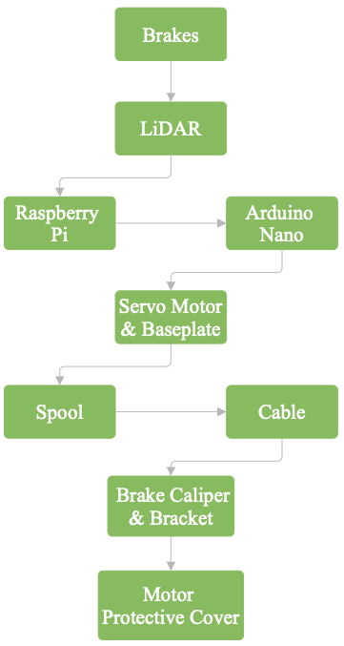
Figure 9: Brakes System Flow Chart

Figure 10’s flow chart maps the braking subsystem hardware tree, from power to motor to mechanism, most branches are outdated. The H-bridge, solenoid, and hydraulic designs we scrapped when the Docyke servo proved simpler, lighter, and more reliable.

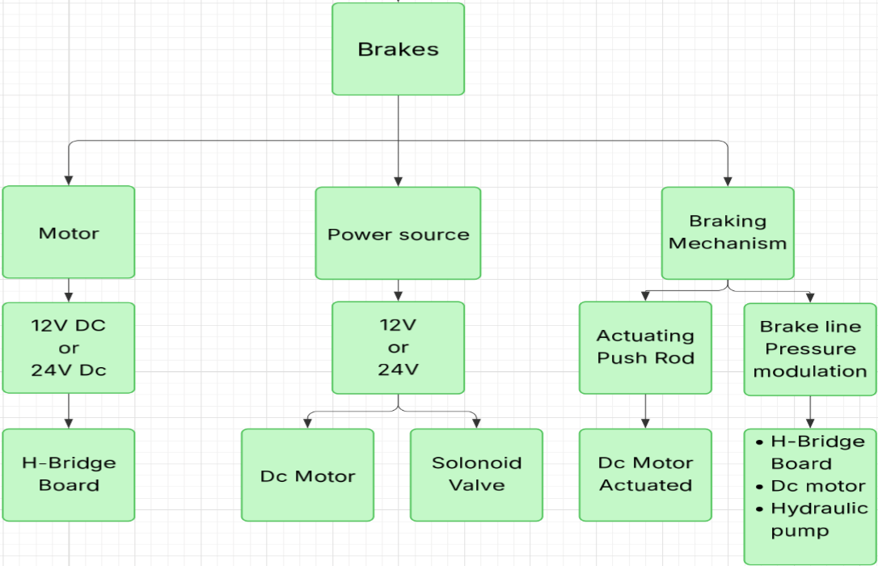
Figure 9: Flow Chart for Brake Sub-Team's Components

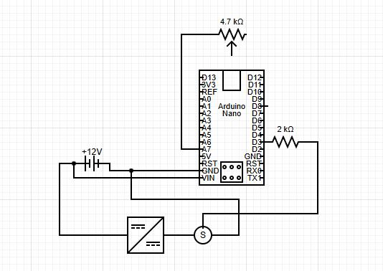
Figure 10: Electrical Assembly for Braking Mechanism
Figure 11 shows the basic electrical hookup for the brake servo: Arduino Nano sends a PWM pulse to the Docyke’s signal pin, while the servo gets its own 24V power feed from the battery. Our EE team will have an updated chart that includes a Raspberry Pi.
Steering
For further understanding of the steering mechanism, the flow chart in Figure 12 is useful for displaying the component hierarchy. The design centers around the kart frame and existing steering system. The three main components of the existing steering system are the steering wheel, column, and axle. Attaching the motor and electrical box to the frame allows for ease of mounting. With the gear box being mounted to the frame, it allows the steering column to turn freely once the mechanism is installed.

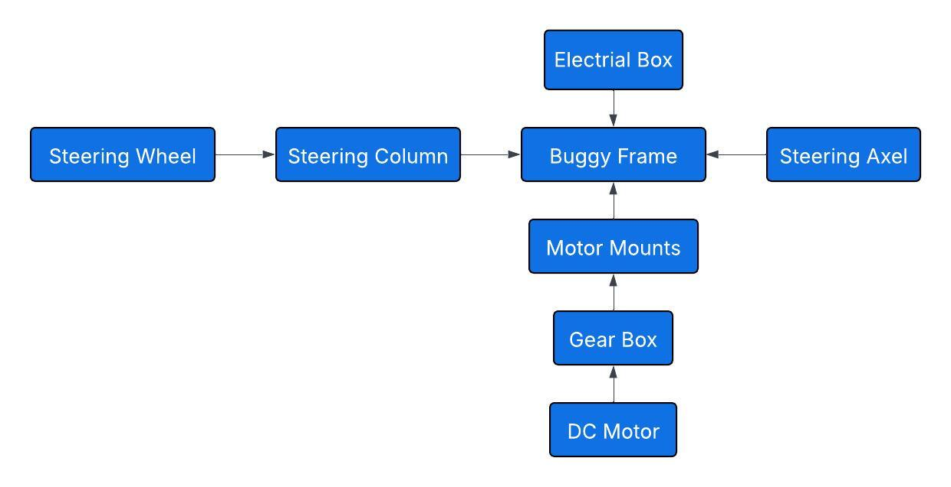
Figure 11: Flow Chart for Steering Mechanism
Figure 13 shows a functional decomposition chart of the steering mechanism. This chart highlights the three main functions that make up the steering components as sensors, control systems, and mechanisms used. The sensors ensure that autonomous requirements are met and include LiDar, collision detection, and data recognition. These sensors and the mechanisms will be controlled using an Arduino Nano within the electrical box. The mechanisms ensure the mechanical work needed to allow autonomous driving is done through the servo motor and 2:1 gear system.
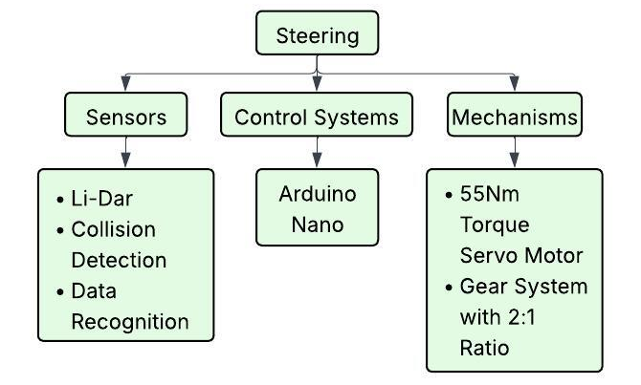
Figure 12: Functional Decomposition Chart for Steering Mechanism
The electrical assembly for the system can be seen in Figure 14. The assembly is made up of $10 kΩ$, and $2 kΩ$ resistors, a 12-volt battery, a motor, the Arduino Nano, a few switches, and wires. This setup will eliminate the risk of overloading the system or reversing the current.

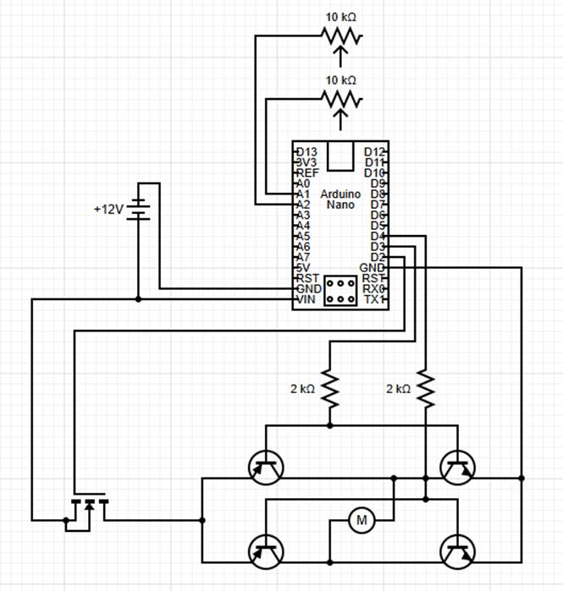
Figure 13: Electrical Assembly for Steering Mechanism
Throttle
The chart below in Figure 15 illustrates the flow chart of the throttle control system, which integrates sensing, control, and mechanical actuation. Below that is Figure 16, which adds specifics on what type of technology each subsystem uses. Sensor inputs from a 3-point camera provide collision detection and data recognition, which are processed by the control system consisting of an Arduino Nano and a DM556 CNC stepper driver. Based on this input, the control system commands the mechanical components, a NEMA 23 stepper motor and a 10 kΩ potentiometer, to read and regulate the throttle position accurately.
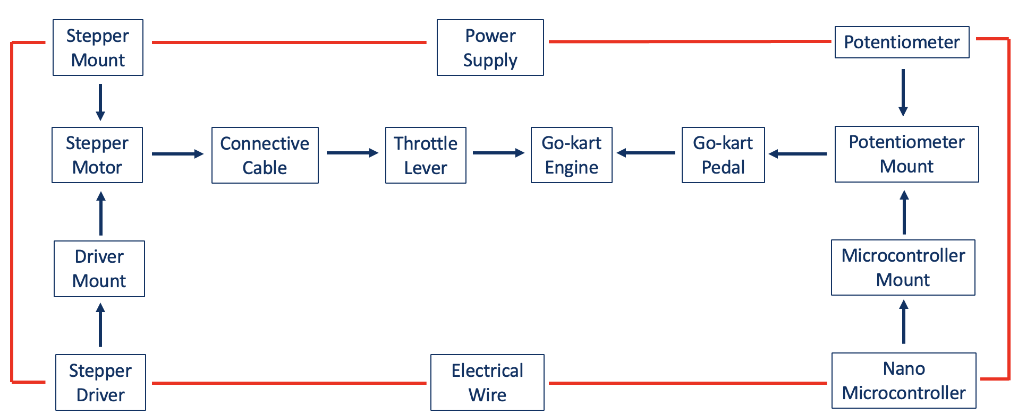
Figure 15: Throttle Mechanism Flow Chart
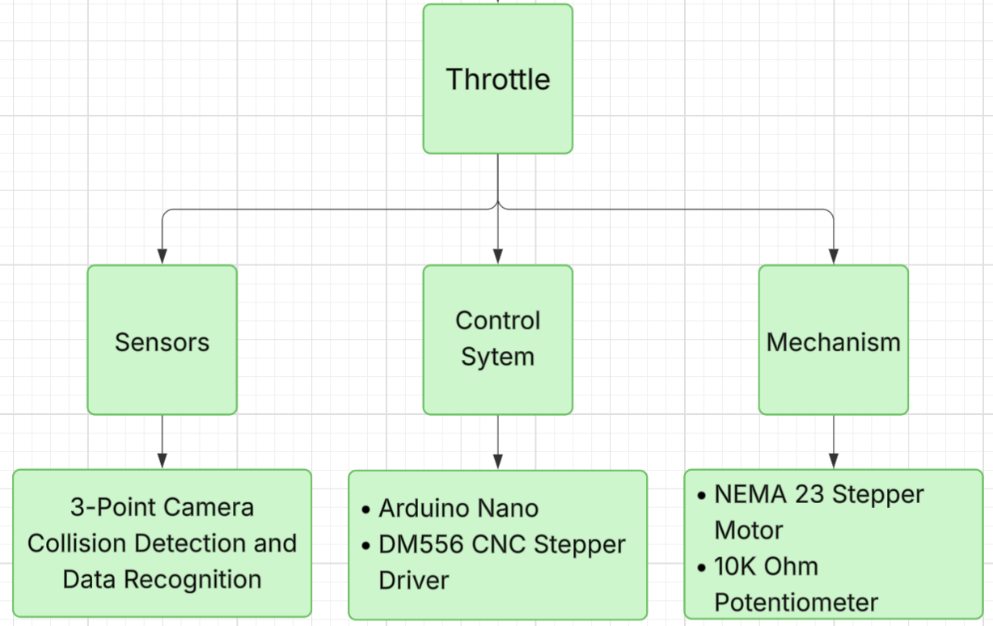
Figure 16: Throttle Functional Decomposition

The throttle wiring diagram shown below in Figure 17 illustrates an Arduino Nano controlling a DM556 motor driver and a NEMA 23 stepper motor. The stepper motor is mounted on the back of the kart and attached to the throttle lever. With an encoder mounted on the shaft, the system ensures accurate measurement of the motor angle.

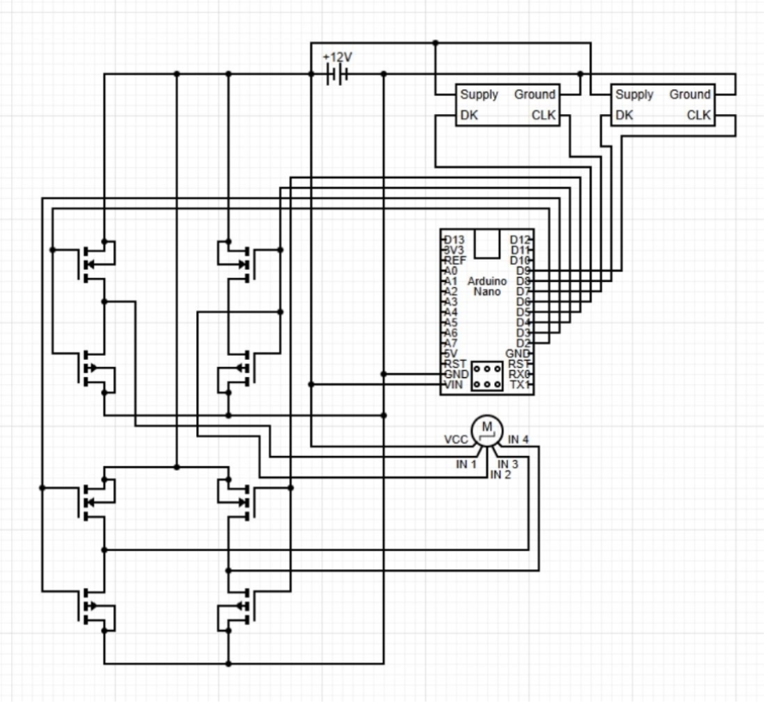
Figure 17: Electrical Assembly for Throttle Mechanism

Moving Forward
The team is largely focused on testing their designs to obtain data, optimize their findings, and improve several aspects of each individual design. Preparing the next steps will ensure accountability in each sub-team and improve the designs further.

Brakes
The next step for the brake sub team is preparing the subsystem for a first major test by Friday, January 30th. In preparation for these tests, the brake caliper mount and spool need to be machined from steel and aluminum, respectively. Following these tests, it is expected that an analysis will be done on the forces placed on the system, particularly examining the screws used, the spool, and the caliper mount. From there, optimization of every part will be done to minimize the chances of failure.

Steering
For the steering subfunction, the steering sub-team is looking to move from PLA printed parts to metal. The sub-team plans to start manufacturing their gearbox and purchase steel gears from the market. The motor casing proposition will be dropped. Instead, mounting the motor will move in a different direction by using a steel plate hooked on the front rack of the buggy with bolts and nuts for attachment. Additionally, there are plans to reprint the electrical box due to the bolt holes being too small. Once the gearbox is finished and the gears have been attached to the motor, the sub-team will move forward with designing and calculating factors for a mechanical failsafe.

Throttle
Based on the throttle’s current design, the sub-team plans to reorder certain mechanisms for a more functional, safety-oriented design. Specifically, the current placement of the stepper motor poses a safety risk due to the location of the pull-start and tension from the intersecting spool. To improve this design, the stepper will be placed towards the South end of the kart, closer to the throttle lever, using a Bowden cable. The Bowden cable will eliminate cable intersection to offer more space around the motor, and it will attach directly to the pre-existing throttle lever. Moreover, this design also allows for the current throttle line to stay in place when the go-kart switches from autonomous mode to manual. Using this newly improved design, the go-kart can employ the electrical components to drive autonomously, or it can switch to the control of the driver by pressing a kill-switch button to shut off the stepper and engage the manual pedal.

Conclusion
Boeing Autonomous has worked carefully throughout the last semester to provide accurate information regarding the contents of all engineering calculations used to construct an autonomous go-kart. Each sub-team has developed a complex plan within its capabilities to account for how each mechanism will work with one another to have the go-kart drive itself following safe and precise requirements. Using the described diagrams, methods, calculations, and charts, the go-kart is on track to be autonomous within the coming months. Moreover, the team plans to continue clear communication with Professor Willy and their clients at Boeing to fulfill all deliverables efficiently and accurately. Trials and testing continue to be a crucial aspect for each sub-team as they define what mechanisms work and which ones need to be improved. Nonetheless, these changes will inform each sub-team more about their mechanisms and improve their design for a fully optimized actuation system built to autonomously control the go-kart.

Appendix
The following information details the associated work used to calculate and define all values described in the main contents of the engineering calculations summary.

Brakes
We determined the system achieves the required clamping force of 221 N, producing 38 N of cable tension and requiring only 3 Nm of servo torque.
Measurements | Values & Units
$$τ_{Rotor}= Rotor Torque$$ | 11.5Nm
$$τ_{Required}= The torque needed to lock rear wheels$$ | 3Nm
$$τ_{Max}= The motors\max{t}orque output$$ | 35Nm
$$μ_{Pad on Rotor}=Friction Coefficient between pad and rotor$$ | 0.42
$$r_{Brake Pad Radius}= Mechanical caliper brake pad radius$$ | 0.062m
$$r_{Spool Radius}= Radius of spool loacted on the motors key shaft$$ | 0.017m
$$F_{Max}=Clamping force needed to produce torque value$$ | 221N
$$M_{Me. Advantage}=\frac{Me. calipers arm length}{spool radius }$$ | 2.94
$$T_{Cable}= Force in the cable$$ | 38N
$$η_{System Efficiency}=Efficiency of brake system$$ | 0.94

Equations (1-4):
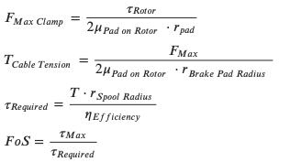

Steering
Variables required for all steering analysis.
Measurements | Values | Units
$S_{y}$=Yield Strength | 370 | MPa
F=Force Required to Move Steering Wheel | 73.4 | N
$A_{p}=$Area of Pinion Set Screw | 7.07 | mm^2
$A_{g}$=Area of Gear Set Screw | 19.63 | mm^2
$N_{g}$=Number of Gear Teeth | 50 | T
$N_{t}$=Number of Pinion Teeth | 20 | T
$d_{g}=$Diametral Pitch of Gear | 78 | mm
dp=Diametral Pitch of Pinion | 33 | mm
bg=Face Width of Gear | 12 | mm
bp=Face Width of Pinion | 10 | mm
mtgModule of Gear mt) | 1.56 | mm
mtp=Module of Pinion mt) | 1.65 | mm
Ko=Overload FactorKo | 1.00
Kv=Dynamic FactorKv | 1.20
Ks=Size Factor ($K_{s}$) | 1.00
KH=Load-Distribution Factor KH | 1.196
KBg=Rim-Thickness Factor of Gear KB | 0.668
KBp=Rim-Thickness Factor of PinionKB | 0.085
YJg=Bending-Strength Geometry Factor of GearYJ | 0.30
YJp=Bending-Strength Geometry Factor of Pinion YJ | 0.33
ZE=Elastic coefficientZE | 8.169 | $$\sqrt{N/{mm}^{2}}$$
$Z_{R}=$Surface Condition Factor | 1
$d_{wl}$ =Pitch Diameter of Pinion | 33 | mm
$Z_{I}=$Geometry factor for Pitting Resistance | 0.098
$S_{t}=$Gear Bending Strength | 379.2 | $$N/{mm}^{2}$$
$Y_{N}=$Strength Stress-cycle Factor | 1.017
$S_{c}=$Gear Contact Strength | 1241.056 | $$N/{mm}^{2}$$
$Z_{N}=$Stress-cycle Factor | 1
$Z_{W}=$Hardness Ratio Factor | 1
$r_{pinion}=$Radius of Pinion | 0.0165 | m
$r_{gear}=$Radius of Gear | 0.034 | m
$θ$ =Angle | 90 | degrees

Equations:
(5) $τ_{allow}=\frac{S_{y}}{\sqrt{3}}$
(6) $τ=\frac{F}{A}$
(7) $σ=W^{t}K_{o}K_{v}K_{s}\frac{1}{bm_{t}}\frac{K_{H}K_{B}}{Y_{J}}$
(8) $σ_{c}=Z_{E}\sqrt{W^{t}K_{o}K_{v}K_{s}\frac{K_{H}}{d_{wl}b}\frac{Z_{R}}{Z_{I}}}$
(9) $S_{F}=\frac{{S_{t}Y_{N}}/{(Y_{θ}Y_{Z})}}{σ}$
(10) $S_{H}=\frac{{S_{C}Z_{N}Z_{W}}/{{(Y}_{θ}Y_{Z})}}{σ_{C}}$

(11) $σ_{all}=\frac{S_{t}}{S_{F}}\frac{Y_{N}}{{Y_{θ}Y}_{Z}}$
(12) $σ_{all,c}=\frac{S_{c}}{S_{H}}\frac{Z_{N}Z_{W}}{Y_{θ}Y_{Z}}$
(13) $FoS=\frac{σ_{all}}{σ}$
(14) $τ_{in}=Ϝ*r_{pinion}\sin\left(θ\right)$
(15) $τ_{out}=Ϝ*r_{gear}\sin\left(θ\right)$
(16) $Gear Ratio=\frac{τ_{out}}{τ_{in}}$

Throttle
The following calculation depicts the RPM the stepper motor will undergo using the dimensions and design of the spool that is directly attached to the stepper motor.
Variables:
Measurements | Values | Units
F_{pedal, min} = force read from fish scale (2kg) | 19.6 | N
d_{pedal} = distance the pedal travels from 0-100% throttle (2.5in) | 0.0635 | m
d_{cable} = distance the cable travels when the pedal is pressed from 0% to 100% throttle | 0.0314 | m
T_{motor, max} = Holding torque of stepper [2] | 2.4 | Nm
conservative value of dynamic torque [3] | 0.5
dynamic torque | 1.2 | Nm
Max turn of spool: | 90 | degrees
Angle of throttle lever turn | 22.7 | degrees

Equations (17-26):
$r_{spool}=\frac{d_{cable}}{θ}$ $τ_{pedal}=\frac{F_{pedal}}{d_{pedal}}$ $F_{cable}=\frac{T_{pedal}}{d_{pedal}}$ $τ_{cable}=F_{pedal}∙r_{spool}$
$s=θ∙r_{spool}$ $I_{total}=I_{spring}+I_{motor}$ $τ_{net}=τ_{stepper}{-τ}_{spool}{-τ}_{friction}$
$t=\sqrt{\frac{2∙s∙I_{total}}{r_{spool}∙τ_{net}}}$ $ν_{cable}=\frac{d_{cable}}{t_{response}}$ $RPM=\frac{ν_{cable}∙60}{π∙d_{spool}}$

Mathematical Computation:
F_pedal = 19.6; % Units: Newtons (N)
d_pedal = 0.0635; % Units: Meters (m)
d_cable = 0.0314; % Units: Meters (m)
Tmax_motor = 2.4; % Units: Newton-meters (Nm)
v_dynamicT = 0.5; % Conservative value of dynamic torque
Tdynamic_motor = 1.2; % Dynamic/Useable Torque of Motor
degree_lever = 22.7; % Angle of throttle lever turn in degrees
degree_spool = 90; % Angle the spool will turn in degrees
I_motor = 0.000053; % Inertia of Stepper Motor in kg*m^2
T_stepper = 1.2; % Useable Torque in Stepper in Newton-meters (Nm)
T_spring = 0.03924; % Torque of Return Spring in Newton-meters (Nm)
T_friction = 0.05; % Estimated Torque due to ground in Newton-meters (Nm)

rad_lever = deg2rad(degree_lever)
rad_spool = deg2rad(degree_spool)

r_spool = d_cable./rad_spool
d_spool = r_spool*2

I_spool = 1.5*(r_spool^2) % Inertia of Spool in kg*m^2

T_pedal = F_pedal*d_pedal
F_cable = T_pedal./d_pedal
T_cable = F_pedal*r_spool;
T_spool = T_cable

s = rad_lever*r_spool

I_total = I_spool + I_motor
T_net = T_stepper - T_spring - T_spool

t = sqrt((2*s*I_total)./(r_spool*T_net))
v_cable = d_cable./t
RPM = (v_cable*60)./(pi*d_spool)

References
[1] “Arizona legislature,” Arizona Legislature, https://www.azleg.gov/arsDetail/?title=28 (accessed Jan. 25, 2026).
[2] ISO 22737 https://www.iso.org/obp/ui/#iso:std:iso:22737:ed-1:v1:en
[3] SAE J2530 / J266 – Steering system performance & testing https://img.antpedia.com/standard/files/pdfs_ora/20221211/sae/SAE%20J266-2018.pdf
[4] https://fscdn.rohm.com/en/products/databook/white_paper/iso26262_wp-e.pdf
[5] https://www.iso.org/obp/ui/#iso:std:iso:12100:ed-1:v1:en
[6] Budynas, Shigley’s Mechanical Engineering Design, 11Th Edition, Si Units. S.L.: Mcgraw-Hill Education (As, 2020.
[7] G. Xia and G. Xia, “45 Steel (S45C/1045): Composition, Heat Treatment & Engineering Properties,” Rapid-Protos, Dec. 30, 2025. https://www.rapid-protos.com/45-steel/ (accessed Jan. 25, 2026).
[8] R. Nalbandian, T. Blais, and R. Horth, “A Recommended New Approach on Motorization Ratio Calculations of Stepper Motors.” Accessed: Oct. 16, 2025. [Online]. Available: https://ntrs.nasa.gov/api/citations/20150004072/downloads/20150004072.pdf
[9] E. Oberg and C. J. Mccauley, Machinery’s handbook : a reference book for the mechanical engineer, designer, manufacturing engineer, draftsman, toolmaker, and machinist. New York: Industrial Press, 2012.
[10] H. Olsson, K. J. Åström, C. Canudas de Wit, M. Gäfvert, and P. Lischinsky, “Friction Models and Friction Compensation,” European Journal of Control, vol. 4, no. 3, pp. 176–195, Jan. 1998, doi: https://doi.org/10.1016/s0947-3580(98)70113-x.
[11] E. Oberg and C. J. Mccauley, Machinery’s handbook : a reference book for the mechanical engineer, designer, manufacturing engineer, draftsman, toolmaker, and machinist. New York: Industrial Press, 2012.
[12] J. L. Meriam and L. G. Kraige, Engineering mechanics. Vol. 2, Dynamics. Hoboken, N.J.: Wiley ; Chichester, 2012.
[13] W. F. Milliken and D. L. Milliken, Race car vehicle dynamics. Warrendale, PA, USA: SAE International, 1995.
[14] R. Limpert, Brake design and safety, 3rd ed. Warrendale, PA, USA: SAE International, 2011.
[15] J. E. Shigley, C. R. Mischke, and T. H. Brown, Shigley’s mechanical engineering design, 11th ed. New York, NY, USA: McGraw-Hill Education, 2020.
[16] Docyke, “350 kg·cm high-torque digital servo datasheet,” Docyke Technology Company, 2022. [Online]. Available: https://www.amazon.com/dp/B09XDXSFRR
[13] H. Olsson, K. J. Åström, C. Canudas de Wit, M. Gäfvert, and P. Lischinsky, “Friction Models and Friction Compensation,” European Journal of Control, vol. 4, no. 3, pp. 176–195, Jan. 1998, doi: https://doi.org/10.1016/s0947-3580(98)70113-x.
[14] J. L. Meriam and L. G. Kraige, Engineering mechanics. Vol. 2, Dynamics. Hoboken, N.J.: Wiley ; Chichester, 2012.

